**Boolean Algebra Worksheet**

1. Write the Boolean expression underneath each symbol:

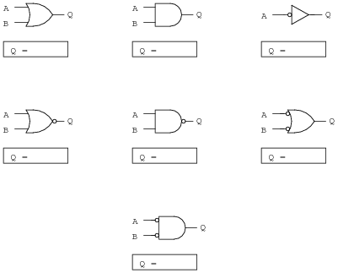

1. Convert each logic circuit into a Boolean expression, writing each gate’s output next to the red arrows:

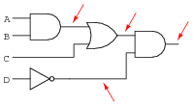

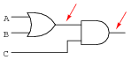

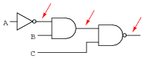

*Boolean Algebra Expression Symbols Reference:*

|  |  |  |
| --- | --- | --- |
| **Logic Gate** | **Boolean Symbol** | **Examples of Use** |
| AND | ∙  x  *  ^  *[no gap or symbol]* | A ∙ B (common)  A x B  A * B  A ^ B  AB (common) |
| OR | +  v | A + B (common)  A v B |
| XOR | + | A + B |
| NOT | !  ¬  ‘ | A (common)  !A  ¬A  A’ |

Answers

